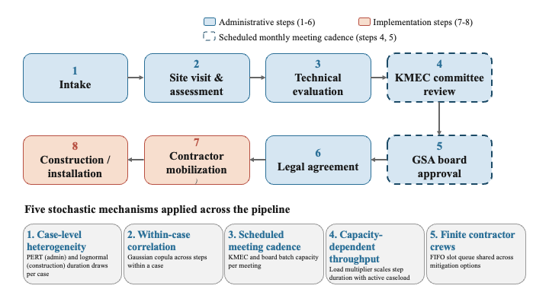
Figure 1 Case-flow pipeline of the Kern Subbasin dry-well mitigation program

Figure 2 Program performance across the spread caseload sweep. (A) Mean case resolution time by annual caseload, with 10th-to-90th-percentile band. (B) Resolution-time target attainment within 180 and 365 days. (C) Dry-well budget exceedance probability.

Figure 3 Multi-year compounding across five model years. (A) Mean resolution time by year. (B) Pending cases at year end, against the 15-case threshold.

Figure 4 Contractor queue sensitivity at a caseload of 15. (A) Mean resolution time by slot count under spread and clustered arrivals. (B) Within-180-day attainment by slot count. (C) Maximum interim supply duration by scenario, on a log scale.
Figure 5 Arrival timing and the household experience. (A) Mean resolution time, spread versus clustered arrivals at matched caseloads.

